FPST 2483 Hands-on Lab-Hazen Williams

Student Name: Liu Xinyu

Data Submitted: 2021/5/13

Data of the laboratory: 2021/4/28

Fire Protection and Safety Technology

Oklahoma State University

## Introduction and Objective

The Objective of this hands-on lab is to form the ability of establish the Hazen-Williams Coefficient of Roughness for a section of piping and through testing the equivalent pipe length of elbows and tee fittings.

## Procedure

1. Watch the lab activity at OSU
2. Using the piping arrangement provided, the pipe diameter and pipe length between gauges should be measured before the lab. Flow is then to be introduced into the piping system and stabilized at three different flow rates as specified by the instructor. At each flow rate, the pressure on the two pressure gauges is to be recorded.
3. An elbow fitting is to be placed into the piping system and the procedure from above using the exact same flows is to be repeated.
4. Repeat again using the same flows with a tee fitting in place of the elbow.

## Results and Calculations

Using an algebraic manipulation of the Hazen Williams formula, an average value of the Coefficient of Roughness is to be determined from the data collected in the first activity.

$P_{f}=\frac{4.52*Q^{1.85}*L}{C^{1.85}*D^{4.87}}$ (Equation 1.1)

Here Pf is the friction loss in psi,

Q is the rate of flow in gpm, and

L is the length of pipe in ft, and

C is the Coefficient of Roughness, and

D is the diameter of pipe in in

According to the conversion of the Hazen-Williams formula,

$C=\sqrt[1.85]{\frac{4.52Q^{1.85}L}{P_{f}D^{4.87}} }$ (Equation 1.2)

For example, in the first row of the table, C should be $\sqrt[1.85]{\frac{4.52{*10}^{1.85}16.6}{1.3*{0.984}^{4.87}} }$ which turns to be 93.43

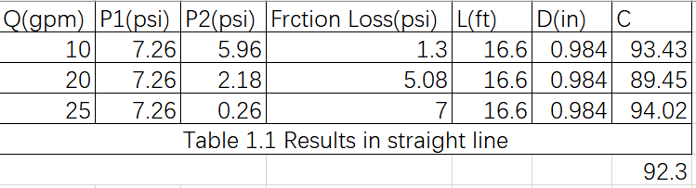

In the table, the Q means the rate of flow in the straight pipe in gpm. P1 mean the value of pressure at the beginning of the pipe, while P2 means the value of the pressure gauge at the end of the straight pipe. L means the measured length of the straight pipe. D means the measured diameter of the pipe and C is the coefficient of roughness for the pipe, which is calculated by the data before and the Hazen Williams formula. The average of the Coefficient of roughness for the pipe, namely C, is 92.3. This value seems a little unregular and that will be explained in the last part of the report.

According to the conversion of the Hazen-Williams formula,

$L=\frac{P_{f}C^{1.85}D^{4.87}}{4.52Q^{1.85}}$ (Equation 1.3)

For example, in the first row of the table, Le should be $\frac{1.26*{92.3}^{1.85}{0.984}^{4.87}}{4.52{*10}^{1.85}}$ which turns to be 15.73, and minus the actual length of the pipes(16.07ft), the equivalent value of the elbow could be calculated in the last column, and , in this case, -0.34

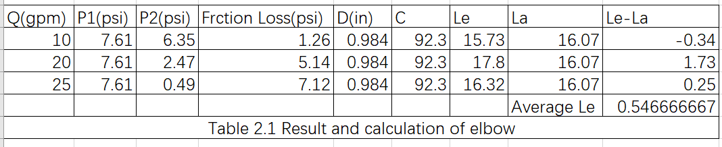

In the table, Q,P1, P2, friction loss and D have the same meaning of the last table. While the C comes from the outcomes of last question, which is 92.3. The Le means the calculated length according to the Hazen Williams formula, which is the theorical value of the pipe and elbow’s equivalent length, the La means the actual length of the pipe which is measured by hand. So, the equivalent length of the elbow should be Le-La, which has an average of 0.55 in, a little lower than the given value in next hands-on Lab. Again, I will explain them in the summary and conclusion.

## Summary and Conclusion

In the first part of the lab, the coefficient of roughness has been calculated through Hazen-Williams formula, though the calculated value is a little lower than regular. The pipes, will have been placed in EMei, a moist city which have over 250 rainy days a year, will be corroded rather quick and thus have a lower C. In addition, the pressure gauge is hard to read, and the gauge we use in China is in Mpa and might thus cause some error since Mpa is a much larger unit than psi. However, the 92.3 is still a coefficient of roughness in common sense, and in general this part should be considerated be correct.

For the equivalent length, there is an attention-getting outcome that the equivalent length for 20 gpm is the highest and is closest to the equivalent length in the given table in NFPA 13. No certain cause might be founded. This might due to the pressure gauge, the way people reading, the unregular corrosion in the pipes or something else. However, the calculated equivalent length for the elbow is 0.55in.

As for the tee fitting, we do not have such equipment here in the SWJTU lab so we cannot complete that part.